Practical 12: Notebook LM Project
Aim :- To create revision notes using Notebook LM.
Objectives
• To generate study guide
• To create flashcards
Materials Required
• Notebook LM
Procedure
1. Create Notebook LM project – Start a new project in Notebook LM to organize your materials and AI-generated outputs in one workspace.
2. Upload two resources – Add two documents or sources to the project so the AI can analyse and reference them.
3. Generate study guide – Use Notebook LM’s tools to create a structured study guide summarizing key concepts from the uploaded resources.
4. Generate flashcards – Automatically produce flashcards that highlight important facts, terms, or ideas for easier review.
5. Review accuracy – Carefully check the summaries and flashcards to ensure all information is correct and reflects the original resources.
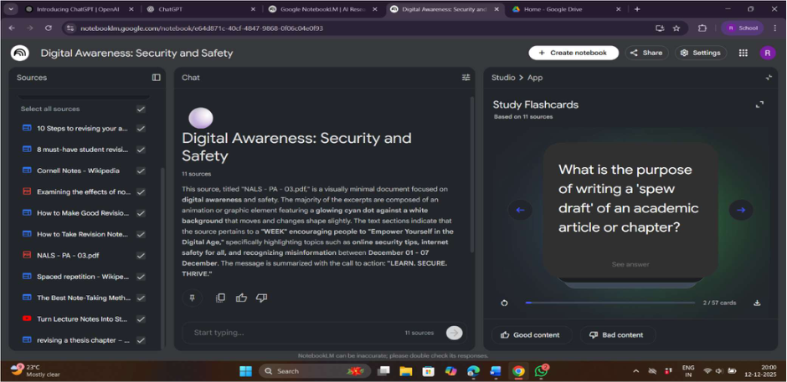
6. Take screenshots – Capture screenshots of the study guide and flashcards to document your work or include them in your submission.
Sol :-

